Capstone 3-1 Ubuntu Server

3-) Screenshot ( My current shell prompt: : fredgy@fredgy:~$ )
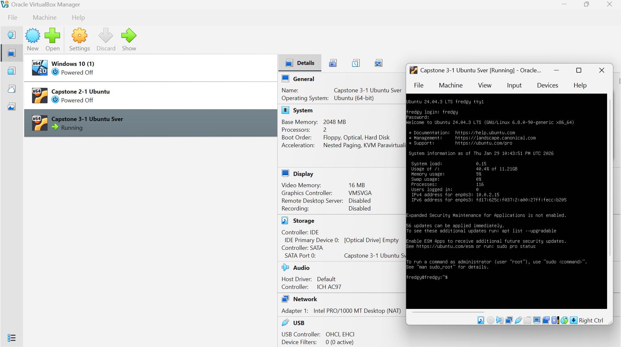

4-) cd mydir : My new shell prompt is : fredgy@fredgy:~/mydir$

7-) The screeshot of the commands I’ve entered so far and their output
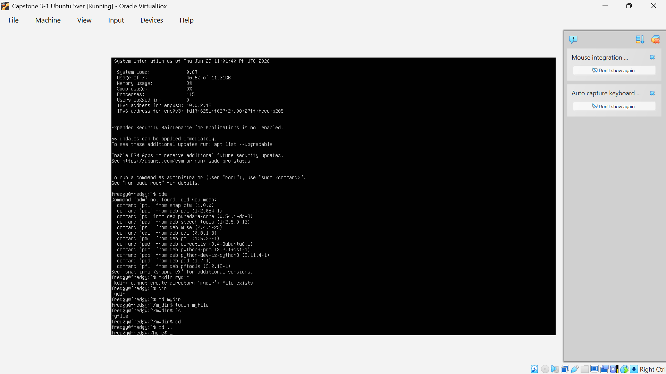

8-) My new shell prompt is: fredgy@fredgy:/home$

18-) My VM’s IP address : 10.0.2.15/24

20-) There are 17 A records listed

